Assignment-3

|  |  |
| --- | --- |
| Assignment Date | 2 October. 2022 |
| Student Name | Preethi B |
| Student Roll Number | 2019504048 |
| Maximum Marks | 2 Marks |

Question :

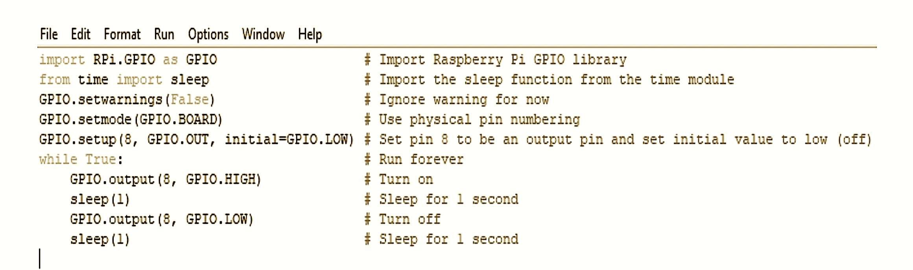Write a python code for Blinking LED for raspberry pi.

Solution:

import RPi.GPIO as GPIO # Import Raspberry Pi GPIO library

from time import sleep # Import the sleep function from the time module

GPIO.setwarnings(False) # Ignore warning for now

GPIO.setmode(GPIO.BOARD # Use physical pin numbering

GPIO.setup(8, GPIO.OUT, initial=GPIO.LOW) # Set pin 8 to be an output pin and set initial value to low (off)

while True: # Run forever

GPIO.output(8, GPIO.HIGH) # Turn on

sleep(1) # Sleep for 1 second

GPIO.output(8, GPIO.LOW) # Turn off

Sleep(1) # Sleep for 1 second

Question :

Write a python code for Traffic lights for Raspberry pi.

Solution:

from gpiozero import Button, TrafficLights #Import button and traffic lights from gpio python library

from time import sleep #Import the sleep function from the time module button = Button(21) #Button-GPIO 21 lights = TrafficLights(25, 8, 7) #Red LED-GPIO 25,Amber LED-GPIO

8,Green LED-GPIO 7

while True: #Run forever button.wait_for_press() #Wait for the button to be pressed

lights.green.on() #Turn on Green LED for 90 seconds sleep(90)

lights.amber.on() #Turn on Amber LED for 10 seconds

sleep(10)

lights.red.on() #Turn on Red LED for 45 seconds sleep(45) lights.red.on() #Turn on Red and Amber for 10 seconds

lights.amber.on() sleep(10)

